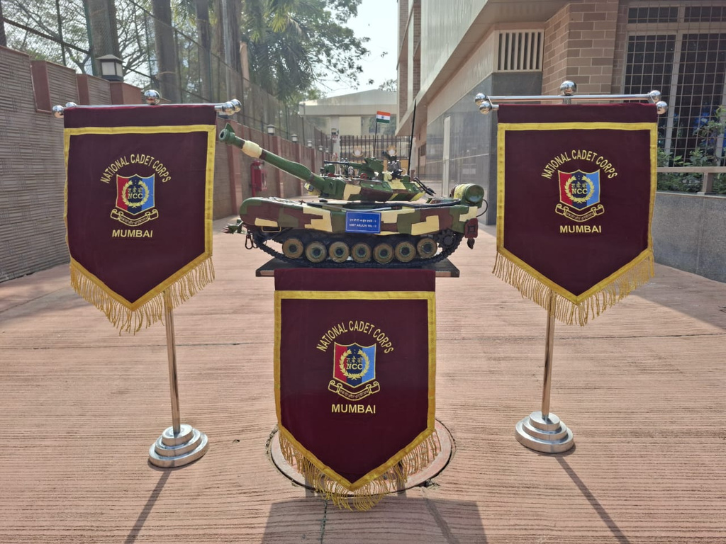

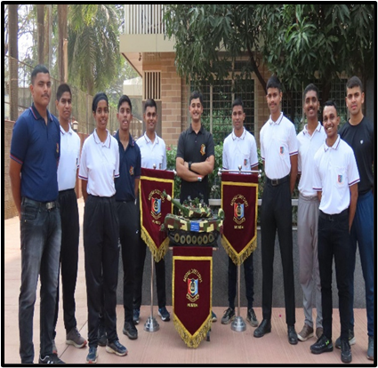

**MBT Arjun Mk-II Tank Modelling Project**

NCC cadets created a model of India's Main Battle Tank using recycled materials, promoting technical education, patriotism, and environmental responsibility. This project developed teamwork, leadership, and problem-solving skills while fostering national pride and discipline. A successful example of integrating practical and sustainable initiatives into cadet training.

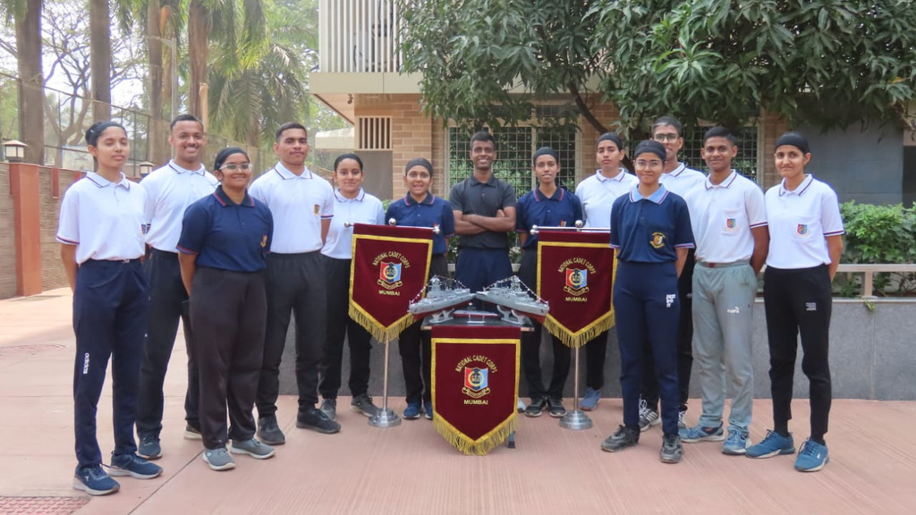

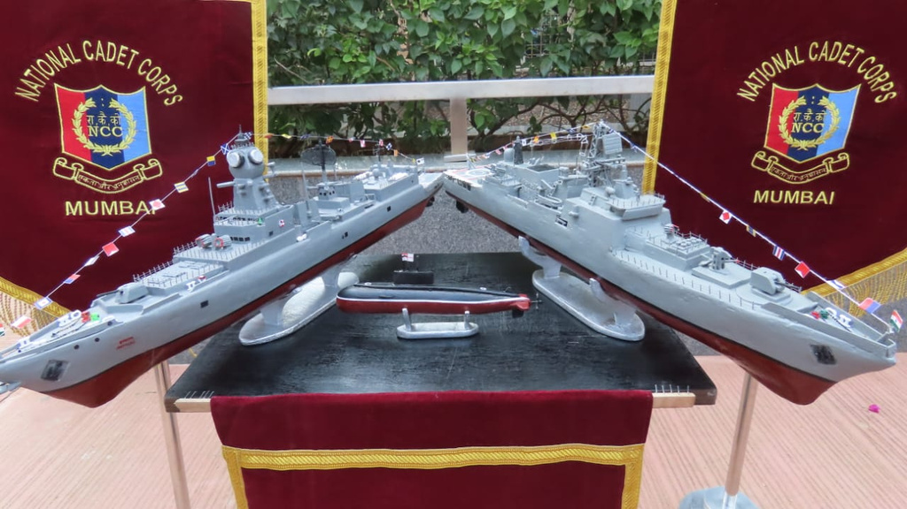

**NCC Naval Wing's Ship and Submarine Modelling Project**

TCET NCC launched a unique project creating scale models of Indian Naval assets (INS Imphal, INS Trishul, INS Brahmaputra, and INS Sindhurakshak) using eco-friendly materials. The project fostered teamwork, innovation, and awareness about India's maritime defence strength, earning appreciation from dignitaries and showcasing cadets' craftsmanship

**More IMAGES OF DESIGN AND DEVELOPMENT PROJECTS are BELOW**





